Hadoop平台部署与运维（1+X）
任务指导书

班级 | 软件2101
姓名 | 张淑倩
学号 | 2130200047
提交日期 | 2023.11.2

软件与通信学院编制
2023年2月

Hive编程练习题

实训任务一 编程题
实训任务 | 任务一：将tearche.txt上传Hadoop服务器上，并将此数据加载到hive数据仓库当中。
编码及运行结果的截图 | hive> load data local inpath '/usr/tools/myData/zhangshuqian.txt' into table teacher;  Loading data to table zsq.teacher  OK  Time taken: 0.945 seconds  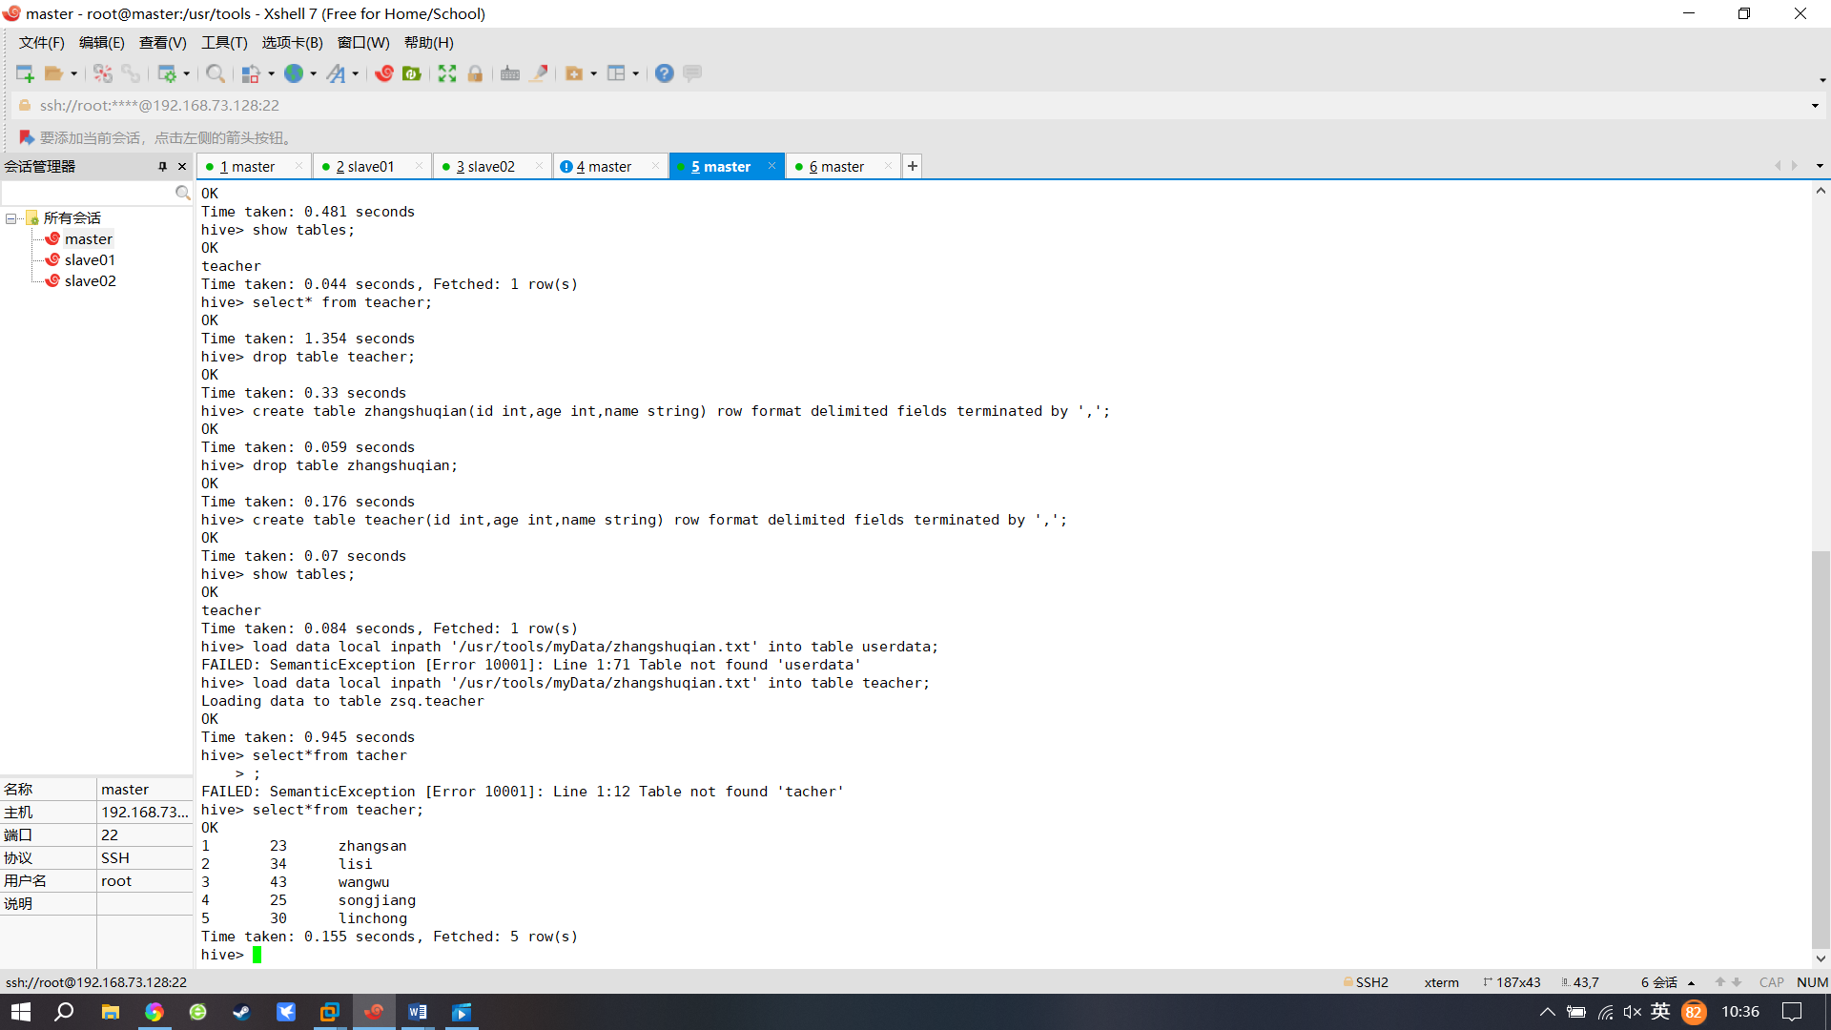
实训任务 | 任务二：查看hive当中的teacher表全部数据
编码及运行结果的截图 | hive> select*from teacher;  OK  1 23 zhangsan  2 34 lisi  3 43 wangwu  4 25 songjiang  5 30 linchong  Time taken: 0.155 seconds, Fetched: 5 row(s)
实训任务 | 任务三：统计Hive当中teacher表中的数据条数
编码及运行结果的截图 | hive> select count(*) from teacher;  Query ID = root_20231102223841_28cd41f5-9075-454f-aefc-695dcc2c6caa  Total jobs = 1  Launching Job 1 out of 1  Number of reduce tasks determined at compile time: 1  In order to change the average load for a reducer (in bytes):  set hive.exec.reducers.bytes.per.reducer=<number>  In order to limit the maximum number of reducers:  set hive.exec.reducers.max=<number>  In order to set a constant number of reducers:  set mapreduce.job.reduces=<number>  Starting Job = job_1698970296123_0002, Tracking URL = http://master:8088/proxy/application_1698970296123_0002/  Kill Command = /usr/tools/hadoop-3.2.2/bin/mapred job -kill job_1698970296123_0002  Hadoop job information for Stage-1: number of mappers: 1; number of reducers: 1  2023-11-02 22:38:48,763 Stage-1 map = 0%, reduce = 0%  2023-11-02 22:38:53,927 Stage-1 map = 100%, reduce = 0%, Cumulative CPU 0.86 sec  2023-11-02 22:39:00,139 Stage-1 map = 100%, reduce = 100%, Cumulative CPU 1.72 sec  MapReduce Total cumulative CPU time: 1 seconds 720 msec  Ended Job = job_1698970296123_0002  MapReduce Jobs Launched:  Stage-Stage-1: Map: 1 Reduce: 1 Cumulative CPU: 1.72 sec HDFS Read: 12354 HDFS Write: 101 SUCCESS  Total MapReduce CPU Time Spent: 1 seconds 720 msec  OK  5  Time taken: 19.549 seconds, Fetched: 1 row(s)  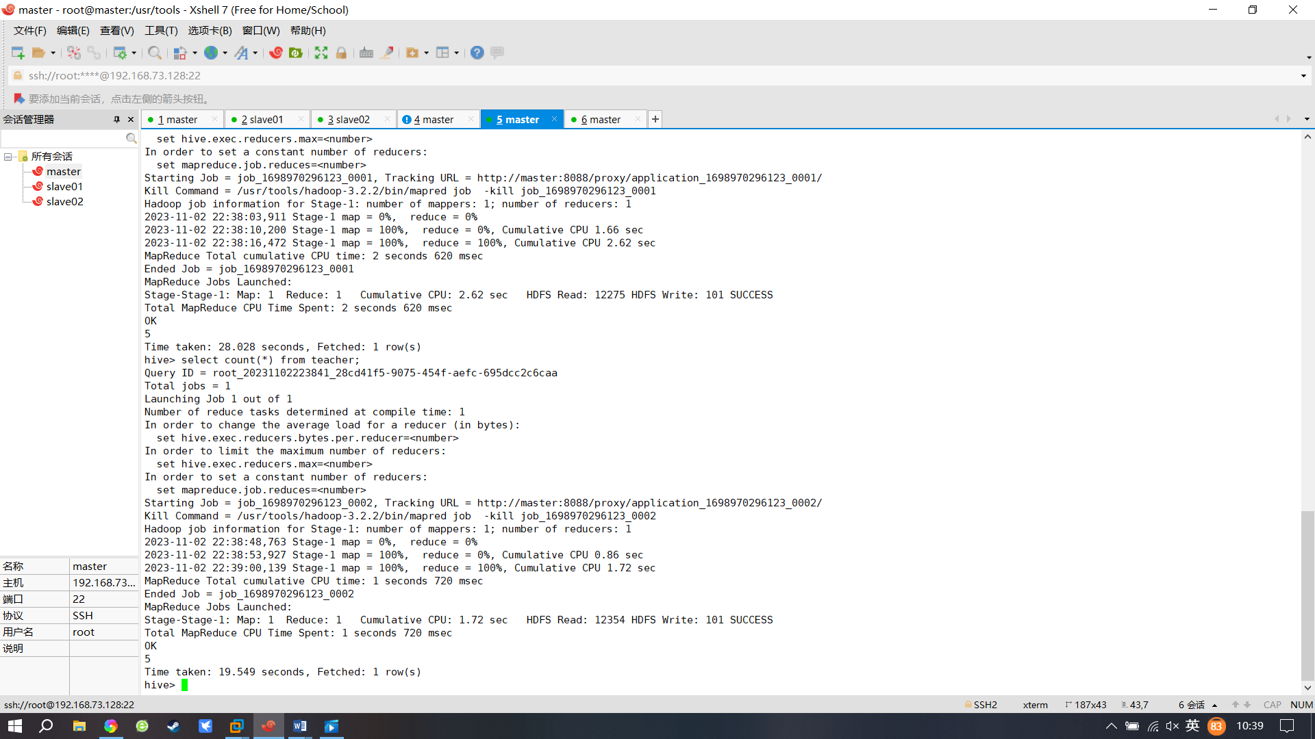
实训任务 | 任务四：查看hive表中tearcher表的结构
编码及运行结果的截图 | hive> desc teacher;  OK  id int  age int  name string  Time taken: 0.056 seconds, Fetched: 3 row(s)  